**1996 EXIT POLL**

--------------------------------------------------------------------------------------------------------------------------------------CSDS exit poll reveals a slow but decisive movement in social basis of Indian politics

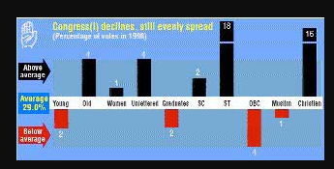

The Centre for the Study of Developing Societies (CSDS), New Delhi, conducted a nationwide exit poll during the Lok Sabha elections in 1996. The poll was the basis of India's first televised election forecast on the evening of May 7, the last day of polling.  
  
The exit poll was carried out on all the three days of polling - April 27, May 2 and May 7. A total of 17,604 voters were interviewed (refusals not included in the count) outside the polling booths as they emerged after casting their ballots. They were asked whom they voted for (with the help of the secret-ballot method), their opinions and about their social background.

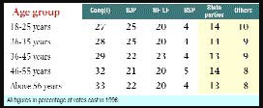

The survey was carried out in 121 Lok Sabha constituencies spread across 20 states and Union territories. Of these, a core sample of 104 constituencies was retained from the two rounds of pre-election surveys undertaken by the CSDS.

These constituencies and polling booths were selected through the multi-stage random sampling (probability proportionate to size) procedure. The core sample was fine-tuned with the help of selective substitution of polling stations and inclusion of some additional constituencies and booths to meet the requirements of the exit poll. The margin of error for the sample is estimated at 2 per cent on either side.

The exit poll data shows that the Congress(I)'s worst-ever electoral drubbing has not altered this basic character of the party. Barring tribal and Christian voters, the support for the Congress(I) still falls within a 10 per cent band (plus or minus 5 per cent) around its average vote. But this is not always an asset. For a party in decline, evenly spread support can actually turn into a liability.  
  
The CSDS exit poll reveals that behind this dramatic electoral verdict is a slow but decisive movement in the social basis of Indian politics. The rainbow of social communities brought together by the Congress(I) in the era of one-party dominance has not disappeared from the politicial horizon, but its slices are beginning to fall apart.

--------------------------------------------------------------------------------------------------------

**1998 EXIT POLL**

--------------------------------------------------------------------------------------------------------**12th Lok Sabha election reveals changing nature of Indian politics**

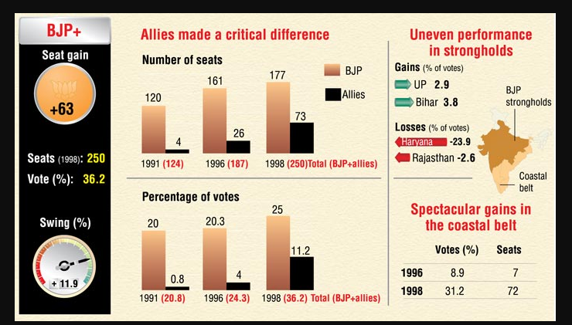

The outcome of the twelfth Lok Sabha election reveals the changing nature of Indian politics. The BJP with its allies has emerged as the largest vote-getter in the country, the first time any party or combine has overtaken the Congress in this respect. Although in 1996, it managed to squeeze a few more votes which made it the largest party in terms of seats, it appeared stuck at around 20 per cent of the vote share, and even with allies could not reach the 25 per cent mark. In 1998, BJP's success is much more apparent. It has broken the 25 per cent barrier in its own right, and the allies add a crucial 6 per cent to the total.

In 1996, the BJP secured merely 9 per cent votes in this region, and a meagre seven seats. This election has seen the BJP front emerge as the dominant player, with 31 per cent of the vote and a total of 72 seats: a quarter of the total up for grabs. In these seven states the vote swing to the BJP alliance was 22 per cent, compared to 4 per cent in the rest of the country.

The BJP takes a smaller share of the seats won by the allies in all these states apart from Karnataka, but its gains add up to a substantial total and enhance its credibility as a contender for government. Overall, the swing to the BJP on its own was 5 per cent.

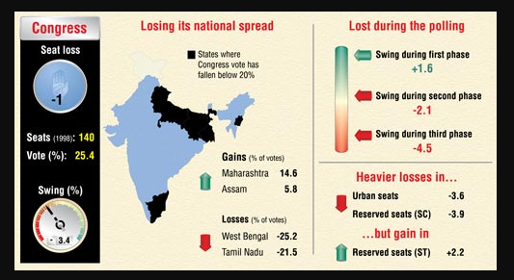

The 1998 election results show that it is not just the influence of dramatic political events that can swing the result over the multiple stages of the election, but a more gradual change in the national mood. In the beginning of February the Sonia wave was at its apex, but each successive round of the election saw people less likely to vote for Congress and the swing to the BJP getting larger.

--------------------------------------------------------------------------------------------------------

**1999 EXIT POLL**

--------------------------------------------------------------------------------------------------------

These elections were held in the backdrop of the Kargil war. The BJP again emerged as the single largest party with 182 seats while the congress could win only 114. This time the regional parties won 158 seats. The BJP was able to form a more stable NDA this time around and this was the first time that a non congress alliance lasted a full five year term. Atal Bihari Vajpayee was sworn in as the Prime Minister for the third time.

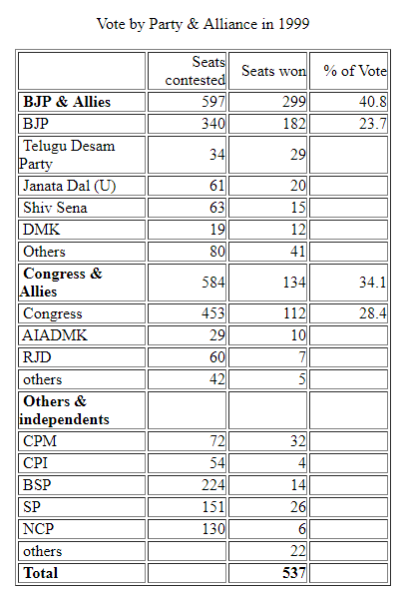

**2004 EXIT POLL**

--------------------------------------------------------------------------------------------------------

L[egislative elections](https://en.wikipedia.org/wiki/Elections_in_India) were held in [India](https://en.wikipedia.org/wiki/India) in four phases between 20 April and 10 May 2004. Over 670 million people were eligible to vote, electing 543 members of the [14th Lok Sabha](https://en.wikipedia.org/wiki/14th_Lok_Sabha). The [Lok Sabha](https://en.wikipedia.org/wiki/Lok_Sabha), or "House of the People," is the [directly elected](https://en.wikipedia.org/wiki/Direct_election) [lower house](https://en.wikipedia.org/wiki/Lower_house) of the [Parliament of India](https://en.wikipedia.org/wiki/Parliament_of_India).

On 13 May, the ruling [Bharatiya Janata Party](https://en.wikipedia.org/wiki/Bharatiya_Janata_Party" \o "Bharatiya Janata Party) (BJP) and its alliance [National Democratic Alliance](https://en.wikipedia.org/wiki/National_Democratic_Alliance_(India)) conceded defeat. The [Indian National Congress](https://en.wikipedia.org/wiki/Indian_National_Congress), which had governed India for all but five years from independence until 1996, returned to power after a record eight years out of office. It was able to put together a comfortable majority of more than 335 members out of 543 with the help of its allies. The 335 members included both the Congress-led [United Progressive Alliance](https://en.wikipedia.org/wiki/United_Progressive_Alliance), the governing coalition formed after the election, as well as external support from the [Bahujan Samaj Party](https://en.wikipedia.org/wiki/Bahujan_Samaj_Party" \o "Bahujan Samaj Party)(BSP), [Samajwadi Party](https://en.wikipedia.org/wiki/Samajwadi_Party) (SP), [Kerala Congress](https://en.wikipedia.org/wiki/Kerala_Congress) (KC) and the [Left Front](https://en.wikipedia.org/wiki/Left_Front_(West_Bengal)). (External support is support from parties that are not part of the governing coalition).

[Congress President](https://en.wikipedia.org/wiki/Congress_President) [Sonia Gandhi](https://en.wikipedia.org/wiki/Sonia_Gandhi) surprised observers by declining to become the new [prime minister](https://en.wikipedia.org/wiki/Prime_Minister_of_India), instead asking former [Finance Minister](https://en.wikipedia.org/wiki/Finance_Minister_of_India) [Manmohan Singh](https://en.wikipedia.org/wiki/Manmohan_Singh), a respected economist, to head the new government. Singh had previously served in the Congress government of Prime Minister [Narasimha Rao](https://en.wikipedia.org/wiki/Narasimha_Rao) in the early 1990s, where he was seen as one of the architects of [India's first economic liberalisation](https://en.wikipedia.org/wiki/Economic_liberalisation_in_India) plan, which staved off an impending national monetary crisis. Despite the fact that Singh had never won a Lok Sabha seat, his considerable goodwill and Sonia Gandhi's nomination won him the support of the UPA allies and the Left Front.

Seven states also held assembly elections to elect [state](https://en.wikipedia.org/wiki/States_and_territories_of_India) governments along with the parliamentary elections.

The Indian general elections in which more than 350 million turned out to vote has produced a big political upset, perhaps the biggest upset in Indian politics. No pollster or media pundit or party leader of any significance predicted a verdict in which the Congress, not the Bharatiya Janata Party (BJP), would emerge as the single largest party in the 14th Lok Sabha. Nobody could foresee the Congress-led alliance ending up 30 seats ahead of the BJP led combine. Nobody could predict the significant increase in the weight of the Left in national politics, with more than 60 seats in a 543-member Lok Sabha and, given these numbers, qualitatively well placed to influence the economic, political and foreign policies of the new Government.

**2009 EXIT POLL**

--------------------------------------------------------------------------------------------------------

With the Congress-led UPA set to return to power, the prediction of the exit polls after the general elections seems to be more accurate this time unlike the 2004 Lok Sabha polls when they were way off the mark.

According to the exit polls projection of the NDTV channel, UPA was projected to emerge as the largest alliance in the Lok Sabha polls with 216 seats. The NDA was expected to get 177 seats.

The exit poll results of the 15th Lok Sabha were much on predicted lines compared to the 2004 parliamentary polls when the exit-poll favourite NDA which was able to secure only 187 seats against the projections of over 240 to 250 seats.

While the NDA's main rival Congress and its pre-poll allies got 216 seats against the projection ranging from 170 to 205 seats in last Lok Sabha projections.

However, this time the projections were more accurate and many channels gave edge to UPA which was coming to be true.  
CNN-IBN gave UPA 185-205 seats while the BJP-led NDA was projected to secure 165 to 185 seats.

India TV channel gave the UPA nearly 195 seats. While it predicted 189 seats for NDA and the Third Front 113. 'Others' were projected to get 14 seats.

Headlines Today channel gave Congress and its allies 191 seats against 180 to BJP and its allies. The Left parties,  
which played a crucial role in the outgoing Lok Sabha with 60 seats, has been projected to get 38.

Live India exit polls gave the Congress 181 seats against BJP's 140.

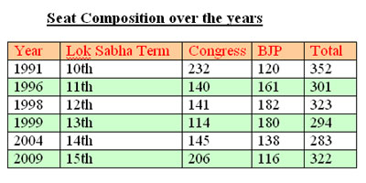

There were 828,804 [Polling Stations](https://en.wikipedia.org/wiki/Polling_Station) around the country – a 20% increase over the number from the 2004 election. This was done mainly to avoid vulnerability to threat and intimidation, to overcome geographical barriers and to reduce the distance travelled by voters.

--------------------------------------------------------------------------------------------------------

**2014 EXIT POLL**

--------------------------------------------------------------------------------------------------------

The BJP-led National Democratic Alliance was placed in a commanding position to form the next government, according to all [exit polls](http://indiatoday.intoday.in/story/lok-sabha-elections-2014-national-post-poll-2014/1/361481.html) released on Monday though the number of Lok Sabha seats it is projected to bag varied from 249 to 340.

According to the India TV-C voter survey, the NDA is poised to bag a majority in the Lok Sabha with 289 seats while the BJP is expected to win 250 seats on its own. The Congress-led UPA was set to win just 107 seats in its worst performance ever, according to the poll.

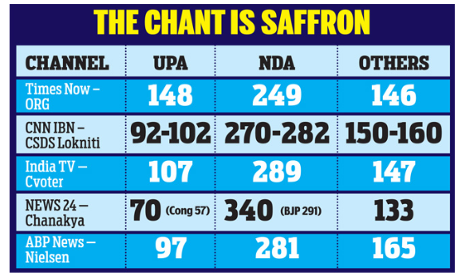

The Times Now-ORG exit poll did not give a clear majority to the NDA but predicted 148 seats for the UPA and 249 for the NDA. It projected a clean sweep for the BJP and its prime ministerial candidate Narendra Modi up north, with the party predicted to win 52 seats in Uttar Pradesh and six seats in Delhi.

The CNN-IBN-CSDS-Lokniti survey projected the NDA would bag about 276 seats while the UPA would not cross the three-figure mark. It projected strong showings by the BJP in Uttar Pradesh, with 45 to 53 seats, and in Maharashtra, where the BJPShiv Sena alliance looked set to bag 33 to 37 seats.

The News 24 Chanakya exit poll predicted a clean sweep for the BJP with 291 seats, making it capable of forming the government on its own. With its partners, the BJP is predicted to bag 340 seats. The Congress is expected to be at an all-time low with only 57 seats while the UPA is predicted to get to 70.

--------------------------------------------------------------------------------------------------------